LUCAS RANCH

HOMEOWNERS’ ASSOCIATION

Rockport, TX Welcome Packet


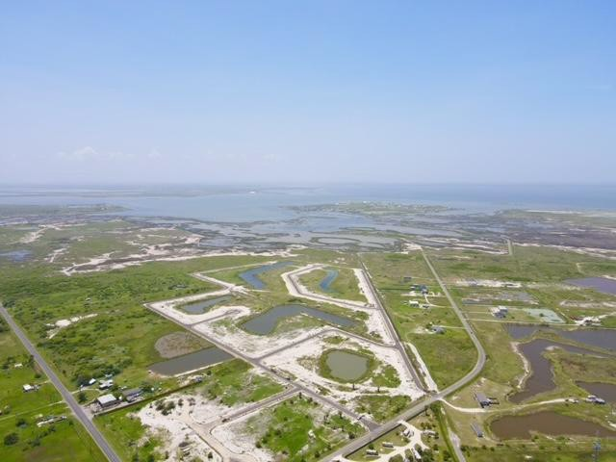

MEDICAL
Physician's Premier ER - Portland, | 361-986-0911
Corpus Christi Medical Center, Bay | 361-761-1000
Christus Spohn Health System | 361-881-3000

UTILITIES
Before You Dig | 811
Constellation Energy | 855-465-1244
Centerpointe Energy Entex | 800-227-1376
TXU Energy | 800- 818-6132
Reliant Energy | 866-222-7100
GEXA Energy | 866-961-9399

TV / INTERNET
Rockport Wi-Fi | 361-790-9434
Spectrum | 877-453-8568
ATT | 800.288.2020

PUBLIC SCHOOLS
Rockport Fulton ISD | 361-790-2212
Live Oak Elementary | 361-790-2260
Rockport-Fulton Middle School | 361-790-2230
Rockport-Fulton High School | 361-790-2220

PRIVATE / PAROCHIAL SCHOOLS
Helpful Numbers
City/County
Rockport Police (non emergency) | 361-729-1111
ARANSAS COUNTY SHERIFF | 361-729-2222
Rockport Volunteer Fire Department (non emergency) | 361-729-5392
NATIONAL POISON CONTROL HOTLINE | 800-222-1222
EMS | 361-729-2112
Rockport-Fulton Chamber of Commerce | 361-729-6445
Town of Fulton | 361-729-5533
City of Rockport (water, sewer, natural gas, garbage and recycling services) | 361-729-2213
County Clerk Office / Voter's Registration | 361-790-0122
County Tax Assessor-Collector | 361-790-0160
Animal Control | 361-790-0151
CP&L (AEP)  Outages/Emergencies | 877-373-4858

Call 911
If you have ANY urgent issues below:
Need an ambulance
See a crime in progress
See a dangerous animal
See a fire
Smell natural gas
Need police
Have been poisoned
See downed power lines
See a tornado

Incarnate Word Academy Catholic School 361-883-0857
Sacred Heart School -
 | 361-729-2672
St. James Episcopal School
 | 361-883-0835
St Pius X Catholic School | 361-992-1343
COLLEGES
Del Mar | 361-698-1200
Texas A&M Corpus Christi | 361.825.5700
OTHER
Texas Parks & Wildlife | 361-790-0312
Texas Sea Grant | 361-749-3049
Wings Rescue Center | 361-205-0892
Aquarium at Rockport Harbor | 361-729-2328
Aransas County Offices | 361-790-0101
Aransas County Appraisal District | 361-729-9733
Aransas County Historical Society | 361-729-5725
Aransas County Independent School District | 361-790-2212
Aransas County Navigation District | 361-729-6661
Aransas National Wildlife Refuge | 361-286-3559
Aransas Pathways | 361-790-0152
Automobile Registration | 361-790-0160
Community Aquatic Center | 361-727-9989
Crime Stoppers | 361-729-8477
Driver's License | 361-758-8680
Goose Island State Park | 361-729-2858
Public Library | 361-790-0153
Rockport Center for the Arts | 361-729-5519

LUCAS RANCH
HOMEOWNERS’ ASSOCIATION
Property Owner Information Sheet PLEASE PRINT
NAME(S):

PROPERTY ADDRESS:

MAILING ADDRESS:

CITY, STATE & ZIP:

PHONE: (H): (W): (CELL):

(W#2): (CELL#2)

E-MAIL ADDRESSES (please print clearly):

Please return as soon as possible, thank you!
Mail to: CKM Property Management PO Box 160
Tomball, TX 77377-0160 Or email to: ckm1@ckm1.com
Or fax to: 281-255-3056

If you have any questions, please call 281-255-3055

Overview
You will receive two containers — one for waste (dark blue lid) and one for recycling (green lid). Household waste and yard debris go in the waste container and will be collected once a week. The container with the green
lid is for recyclable items only and will be collected every other week — on the same day as your waste collection. Please refer to the accompanying calendar for your pick up day.
In addition to the weekly container collection, special pickups of bagged leaves will occur for four weeks in the spring and four weeks in the fall. A total of 12 bags may be placed
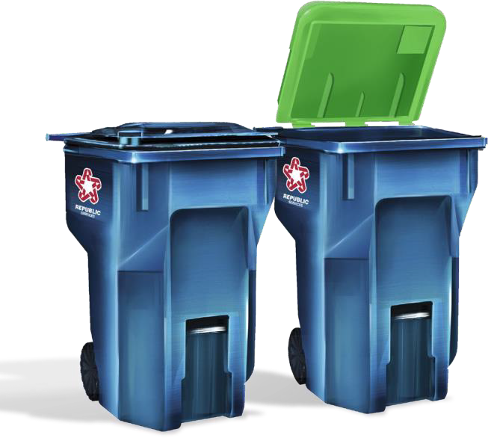
curbside each week and must weigh less than 35 pounds.

Frequently Asked Questions

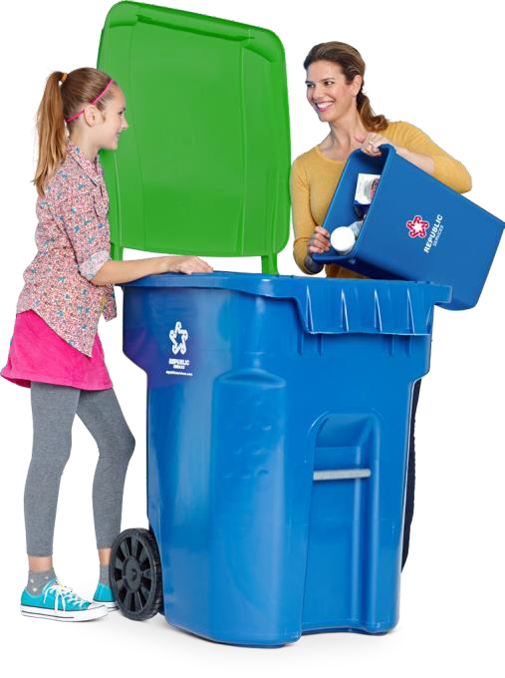

Q: When is waste collected?
City of Rockport, Texas
Waste and Recycling
Guide
Container Collection
A: Waste containers (dark blue lid) are once per week. Recycle containers (green lid) are the same day as the waste containers but every other week. Refer to the accompanying calendar for your specific collection day.
Q: What if I have container changes or a container needs repair?
A: Contact Utility Billing at (361) 729-2213 ext.
234. Another container may be ordered for an additional fee. Please allow up to 7 business days for repairs or exchanges. If you requested the larger container (OR if you didn’t respond to the survey) and would prefer the smaller one, contact Utility Billing. There will be a $20 charge for this initial replacement.
Q: Who do I call if my container(s) are missed on collection day?
A: Contact Utility Billing at (361) 729-2213 ext. 234 as soon as possible to report the miss.
Q: Can I use my old trash cans?


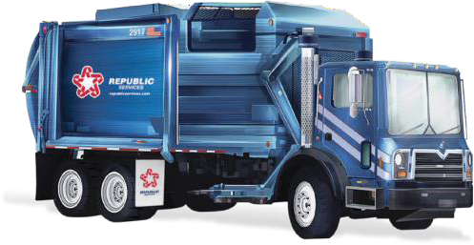
A: No, the automated trucks cannot accommodate other containers.



Please Note Please recycle only the DO NOT RECYCLE:

Household waste must be bagged and the bags placed in the container with the dark blue lid.
- Containers must be set out by 7:00 am on the day of collection or you may be missed.
- Place containers with the wheels against the curb (or edge of pavement if there is no curb) and the front of the container facing the street.
- Containers should be 2 feet apart, 2 feet from trees or bushes, 3 feet from mailboxes, and 5 feet from vehicles.
- All waste and recyclables must be inside the container with the lid closed or mostly closed.

items below:
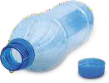
PLASTICS
Recycle plastics #1 thru #7. Look on the bottom of containers for a number inside the recycling arrows.

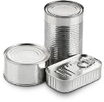

METAL CANS, ALUMINUM FOIL, ALUMINUM FOIL PANS
Recycle all food and beverage metal cans - steel, tin, bi-metal and aluminum.


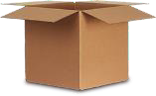

CARDBOARD, NEWSPAPER AND MAGAZINES
You can also include newspaper
Plastic Bags
Plastic Food Wrappers Plastic without Numbers Greasy Food Containers Food or Liquid Waste Glass
Yard Waste Construction Debris Scrap Metal Hazardous Waste Electronics
Cables or Batteries Diapers
Tissue
Bio-hazardous Waste Light Bulbs Ceramics
Dishes or Mirrors Hoses
Toys Clothes Shoes Tools
Plastic Straws Styrofoam
To-Go Lids
Holiday Decorations

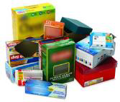
- Small, manageable yard waste (e.g. leaves, tree trimmings) may be placed in your waste container if the lid will close.
- Please rinse all food containers prior to placing them in your recycle container (green lid).
- Bulky items and yard waste that cannot fit into a container can be taken to the Aransas County

Transfer Station, located at 870 Airport Road. Limited numbers of no cost vouchers are available each week. Call Aransas County with questions at
361-790-0162




Container Placement Guide

Place cart at curb or within 3 feet from road with front of cart facing street or alley.
inserts, catalogs, paperback books, phone books & brochures.

PAPER FOOD CONTAINERS
Recycle food boxes including: juice boxes, egg, ice cream & milk cartons, and cereal & pasta boxes.

PAPER
Recycle envelopes, office paper, junk mail, greeting cards & file folders.
Shredded paper should be put in a paper bag.

(361) 729-2213 ext. 234
www.cityofrockport.com

For More Information
Online — Go to www.cityofrockport.com and look for the link to the Finance Department page.
CodeRED — CodeRED is the City’s telephone
notification system used to alert residents of emergencies but also service disruptions,
including sanitation. Click on the CodeRED logo at www.cityofrockport.com to sign up and stay informed.
Telephone — Call Utility Billing at
(361) 729-2213 ext. 234, 8:00-5:00 weekdays.
In Person — Visit representatives of Utility Billing at City Hall, 622 E. Market Street.
To Report Illegal Dumping
Telephone — Call Code Enforcement at
(361) 790-1125.

Online — Use the “Fix It” form on the home page
of the City’s web site.

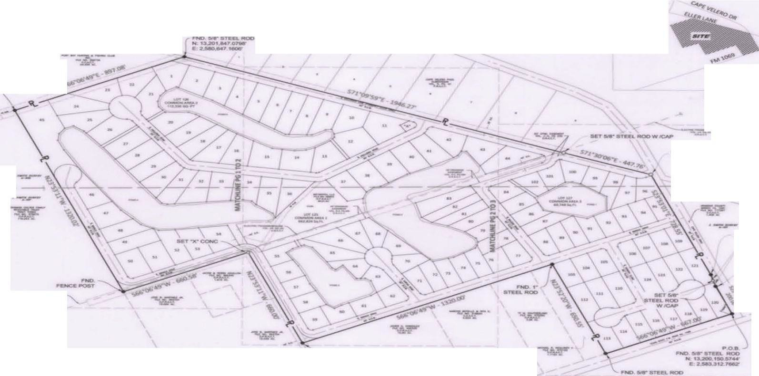
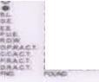
LUCAS RANCH

HOMEOWNERS’ ASSOCIATION

Rockport, TX

Professionally Managed by CKM Property Management 281.255.3055
Ckm1@ckm1.com

